**Shiwangi Mishra - SM9175**

**Rakshitha Kori Raj - RKR316**

**CSGY-6083-B - Principles of Database Systems**

**Final Project Report**

**05/07/2021**

|  |  |
| --- | --- |
| [**Executive summary and Database Design, Constraints**](bookmark://page3) | [**3**](bookmark://page3) |
| [**Software, Language and Database**](bookmark://page6) | [**6**](bookmark://page6) |
| [**Tables, and Table Records**](bookmark://page6) | [**7**](bookmark://page7) |
| [**Screenshots of Various Web pages in RTL Online Library**](bookmark://page8) | [**9**](bookmark://page9) |
| [**Security and Extra Features**](bookmark://page12) | [**21**](bookmark://page21) |
| [**Lessons Learned**](bookmark://page14) | [**31**](bookmark://page31) |
| [**Business Analysis With MySQL**](bookmark://page15) | [**32**](bookmark://page32) |

Executive summary

**Business Case:**

RTL (Read Think and Learn) is a public library. It serves the community by providing access to diversified resources, affordable rental services, free room reservations and various educational events. RTL websites have two users: Librarian and Customer. Both have to login using their username (Email id) and password.

Customers Features: RTL’s website provides its users the capability to register as a customer, rent a book and pay using Cash, Credit, Debit or PayPal. Customers can also reserve study rooms for free. Customers can also register for events of type exhibition using this website.

Liberian: They can view, add, update, delete a new book, topic, room, author, and events (seminars, exhibition). They can send invitation of Seminars to authors using this website. Librarian can also maintain sponsors- Individual or Organisation and the contributions they have made towards an event.

**Our approach:**

We’ve designed a backend database for RTL, originally using Oracle Data Modeler and ultimately with MySQL as backend. Our implementation makes it easy for customer and librarians to perform basic functions by converting file system-based data management to sophisticated centralized database system, while still offering its users an easy and intuitive way to view, manage and edit rental data if necessary.

**Logical and Relational Model:**

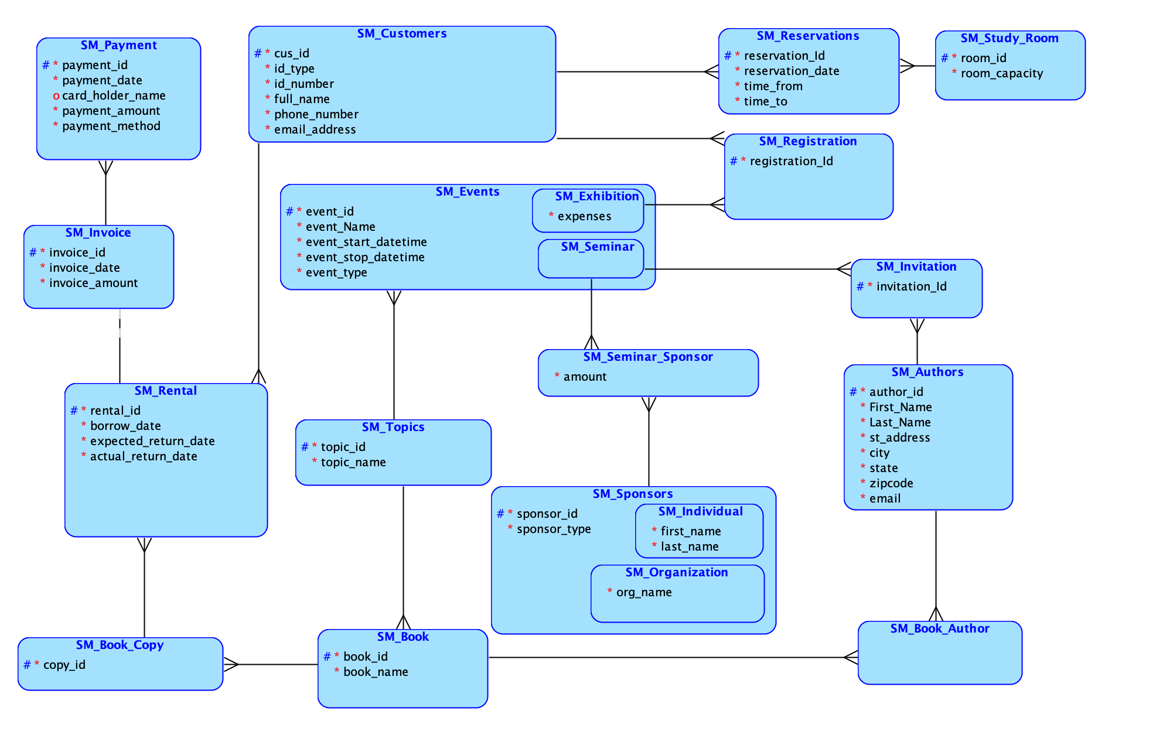

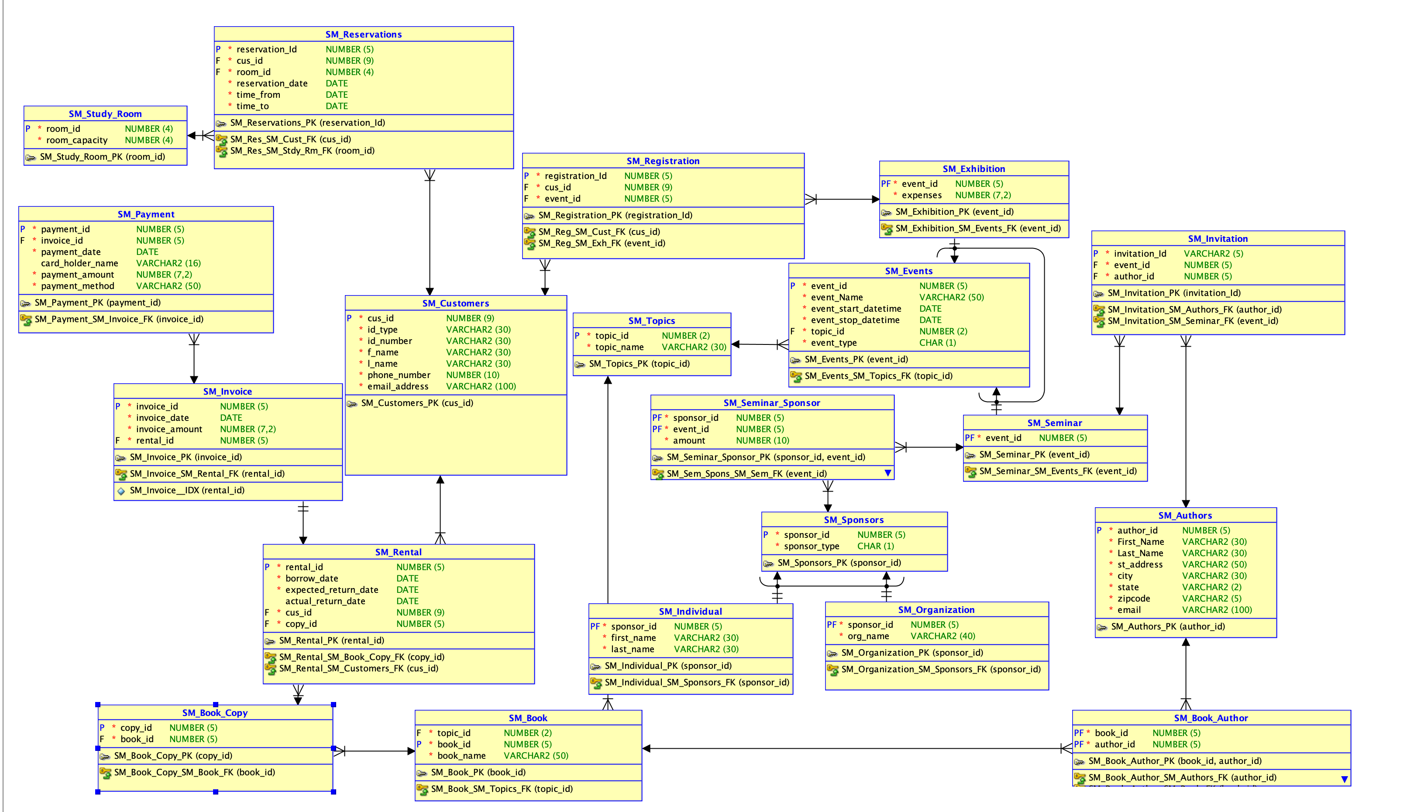

**Business Constraints:**

-- SQLINES DEMO *** Sm_customers to ensure: valid id type is one of Passport, SSN, or Driver License:

**alter** **table** sm_customers **add** **constraint** C_sm_customers_id_type **check** (LOWER(id_type) **in** ('passport', 'ssn', 'driver license'));

-- SQLINES DEMO *** _payment to ensure: payment method type is one of Cash, Credit, Debit or PayPal:

**alter** **table** sm_payment **add** **constraint** C_sm_payment_payment_method **check** (LOWER(payment_method) **in** ('cash', 'credit', 'debit', 'paypal'));

-- SQLINES DEMO *** _payment to ensure: card holder name is not null for payment mentod in Credit, Debit or PayPal and null is allowed for cash:

**alter** **table** sm_payment **add** **constraint** C_sm_payment_card_holder_name_notnull

**check** ((LOWER(payment_method) **in** ('cash', 'credit', 'debit', 'paypal') **and** card_holder_name **is** **not** **null**) **or**

(LOWER(payment_method) = 'cash' **and** card_holder_name **is** **null**));

-- SQLINES DEMO *** reservations to ensure: reservation start time is not greater than reservation end time and reservation’s time slot for a particular date must fall in following four intervals : 8 AM to 10 AM, 11 AM to 1 PM, 1 PM to 3 PM and 4 PM to 6 PM.

**ALTER** **TABLE** sm_reservations **ADD** **CONSTRAINT** C_sm_reservations_time_from_time_to **CHECK**(time_from <= time_to);

**ALTER** **TABLE** sm_reservations **ADD** **CONSTRAINT** C_sm_reservations_time_in_range **CHECK**(

((DATE_FORMAT(time_from, "%H%i") **between** TIME_FORMAT('7:59:00','%H%i') **and** TIME_FORMAT('10:01:00','%H%i')) **and** (DATE_FORMAT(time_to, '%H%i') **between** TIME_FORMAT('7:59:00','%H%i') **and** TIME_FORMAT('10:01:00','%H%i'))) **or**

((DATE_FORMAT(time_from, "%H%i") **between** TIME_FORMAT('10:59:00','%H%i') **and** TIME_FORMAT('13:01:00','%H%i')) **and** (DATE_FORMAT(time_to, '%H%i') **between** TIME_FORMAT('10:59:00','%H%i') **and** TIME_FORMAT('13:01:00','%H%i'))) **or**

((DATE_FORMAT(time_from, "%H%i") **between** TIME_FORMAT('12:59:00','%H%i') **and** TIME_FORMAT('15:01:00','%H%i')) **and** (DATE_FORMAT(time_to, '%H%i') **between** TIME_FORMAT('12:59:00','%H%i') **and** TIME_FORMAT('15:01:00','%H%i'))) **or**

((DATE_FORMAT(time_from, "%H%i") **between** TIME_FORMAT('15:59:00','%H%i') **and** TIME_FORMAT('18:01:00','%H%i')) **and** (DATE_FORMAT(time_to, '%H%i') **between** TIME_FORMAT('15:59:00','%H%i') **and** TIME_FORMAT('18:01:00','%H%i')))

);

**Software, Language and Database:**

We used MySQL, MySQL Workbench for database and Java Hibernate framework to connect to this database through our web platform. For web platform we used - Java Spring Boot as a framework which we hosted locally via Tomcat Server. Java Spring Boot Web App is written in Java using MVC architecture, so Java is our primary language, with additional usage of CSS, JS and HTML to create web pages. We used RESTful style architecture - divided our project in Model,View,Controller and JPA Entities for database Entities mapping, and services layer for additional features.

**Tables, and Table Records:**

Select count(*) as sm_Topics_count from sm_Topics;

Select count(*) as sm_Authors_counts from sm_Authors;

Select count(*) as sm_Book_Author_counts from sm_Book_Author;

Select count(*) as sm_Book_counts from sm_Book;

Select count(*) as sm_Book_Copy_counts from sm_Book_Copy;

Select count(*) as sm_Rental_counts from sm_Rental;

Select count(*) as sm_invoice_counts from sm_invoice;

Select count(*) as sm_payment_counts from sm_payment;

Select count(*) as sm_Events_counts from sm_Events;

Select count(*) as sm_exhibition_counts from sm_exhibition;

Select count(*) as sm_seminar_counts from sm_seminar;

Select count(*) as sm_invitation_counts from sm_invitation;

Select count(*) as sm_registration_counts from sm_registration;

Select count(*) as sm_Customers_counts from sm_Customers;

Select count(*) as sm_Sponsors_counts from sm_Sponsors;

Select count(*) as sm_individual_counts from sm_individual;

Select count(*) as sm_organization_counts from sm_organization;

Select count(*) as sm_seminar_sponsor_counts from sm_seminar_sponsor;

Select count(*) as sm_Study_Room_counts from sm_Study_Room;

Select count(*) as sm_Reservations_counts from sm_Reservations;

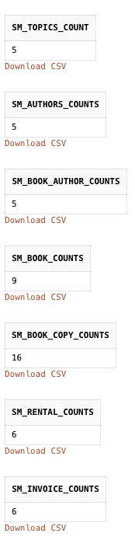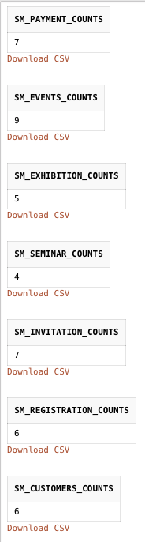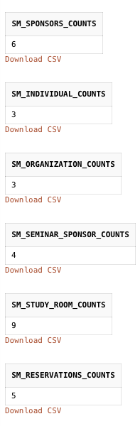

**Transaction and Session Implementation for Concurrency:**

**We have used @Transactional to annotate the methods which when called will be wrapped in a transaction.**

The transactional annotation defines the scope of a single database transaction. The database transaction happens inside the scope of apersistence context.

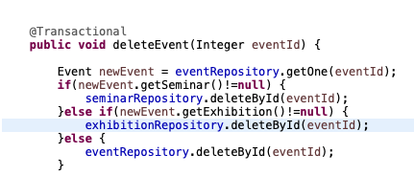

Apart from that we opened a new session and closed it once the transaction is over to support concurrency.

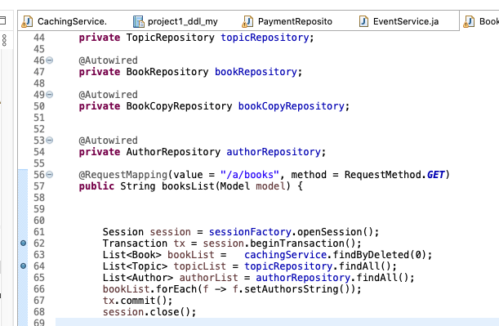

**Screenshots of sessions, pages, menus of your Web Application:**

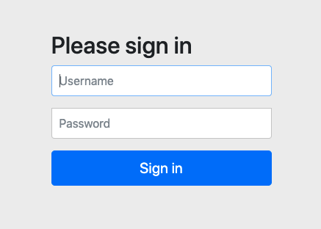

Login page

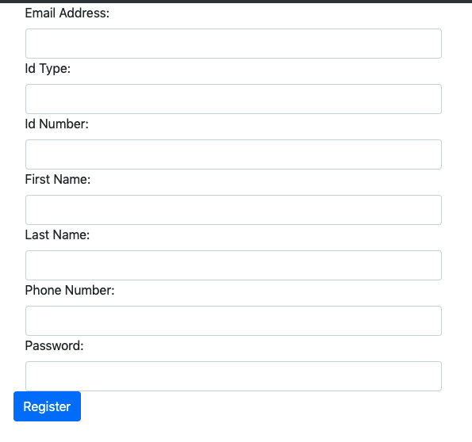

Registration page

**Author CRUD operation:**

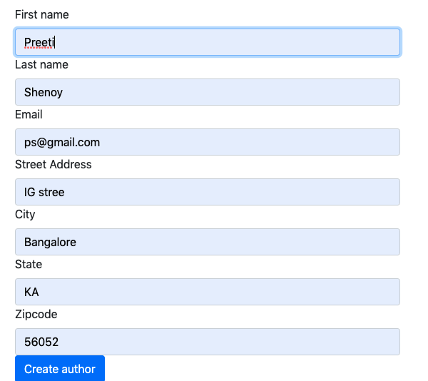

**Author create**

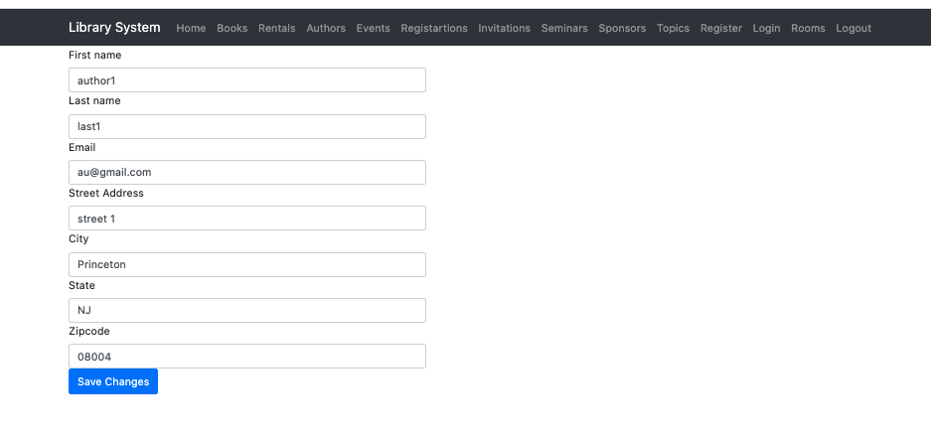

Edit Author Page

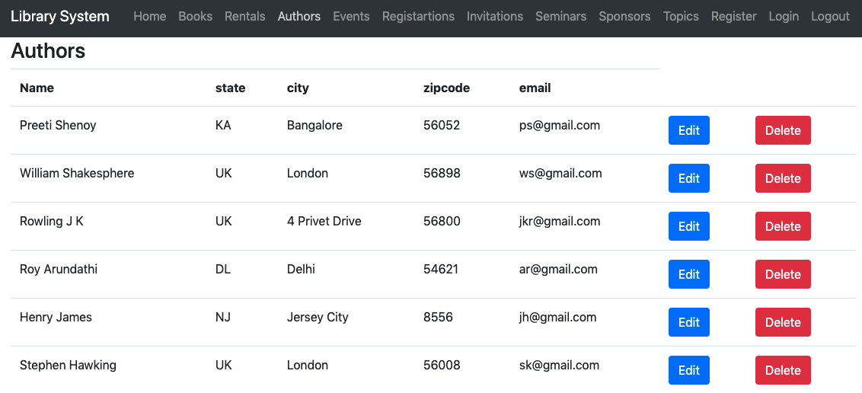

Author read

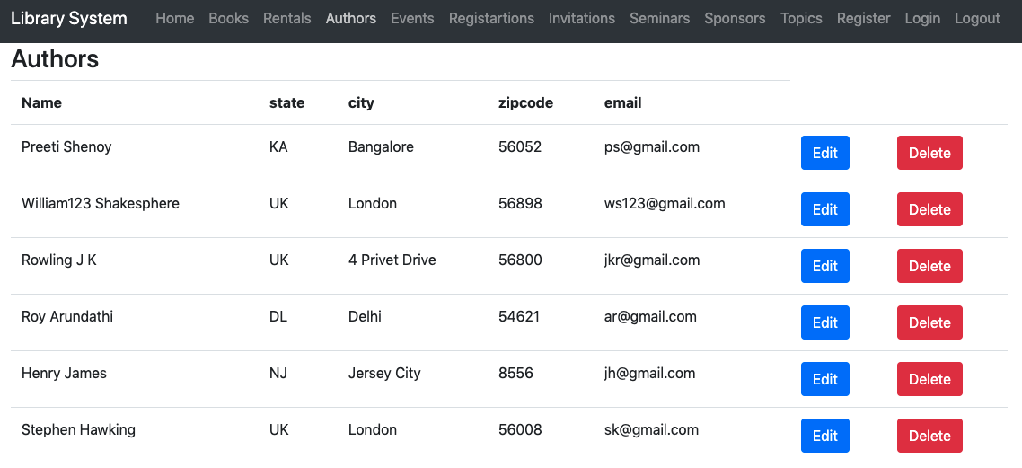

Author update

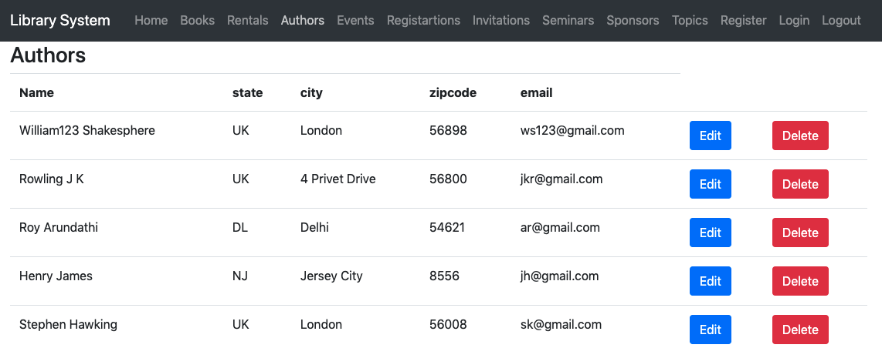

Author delete(Deleted the author Preeti Shenoy)

**Event CRUD operations:**

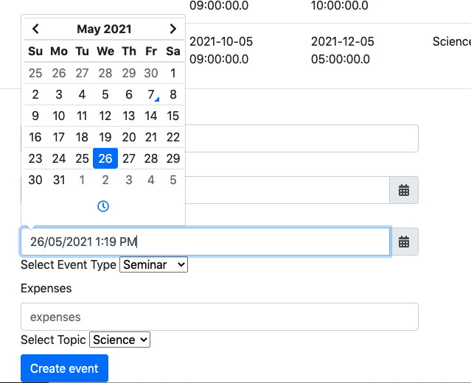

Event Create

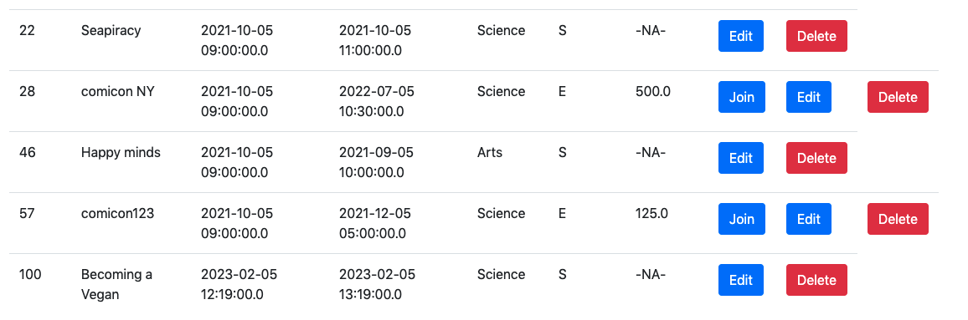

Event Read

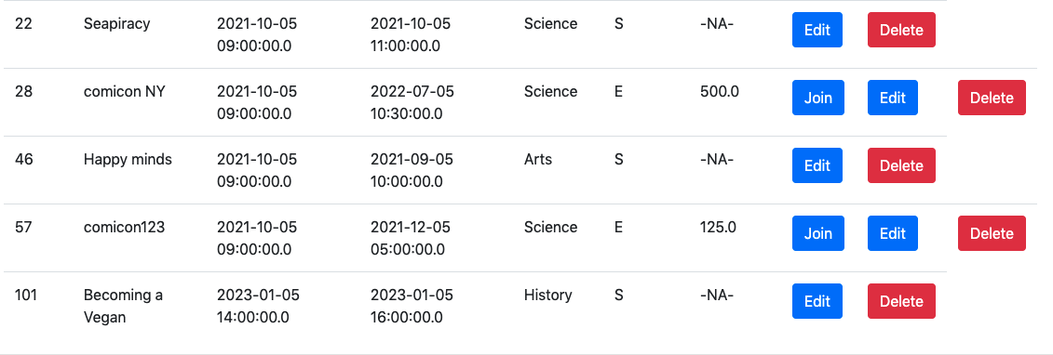

Event update(Seminar- Becoming a Vegan date has been updated)

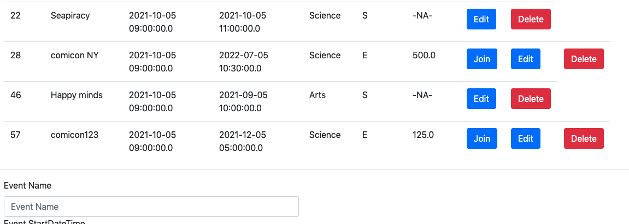

**Event Delete**

**Registration CRUD operations:**

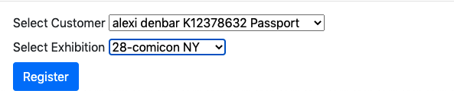

Registration create

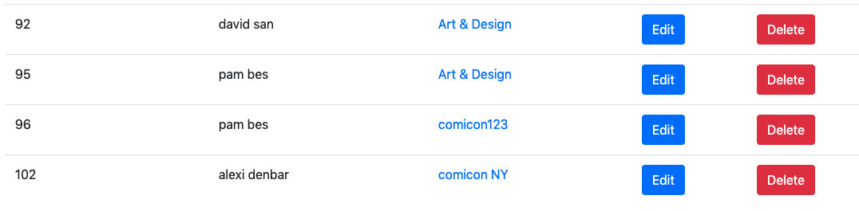

Registration read

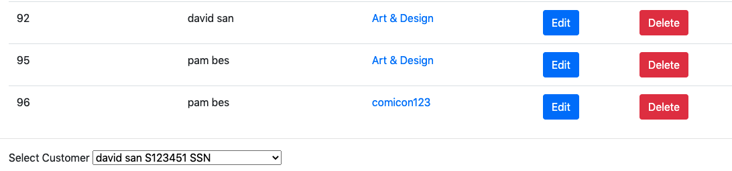

Registration delete

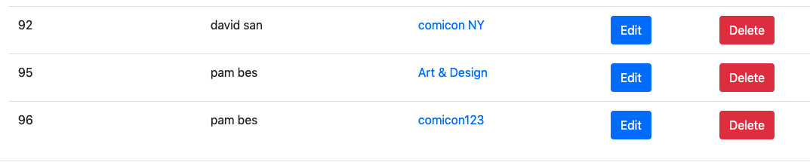

Registration update(David San event name has been updated from Art & Design to comicon NY)

**Invitation CRUD operation:**

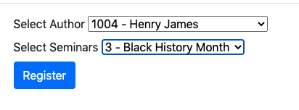

Invitation create

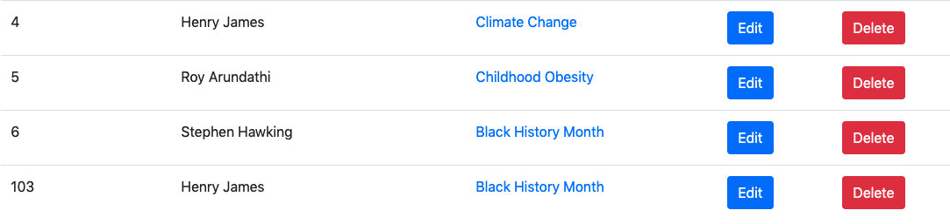

Invitation read

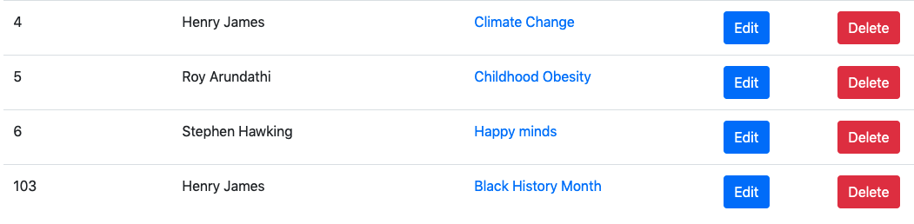

Invitation update (Stephen Hawking event has been changed from Black History Month to Happy minds)

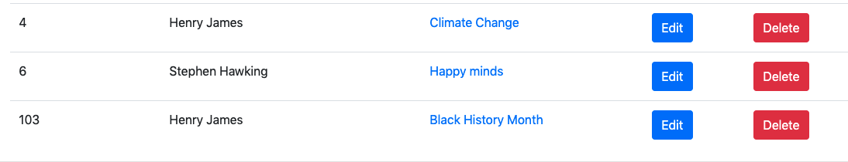

Invitation delete

**Seminar sponsor CRUD operations:**

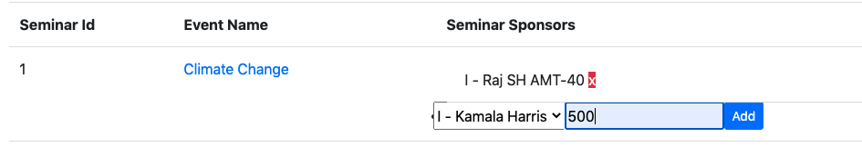

Sponsor create

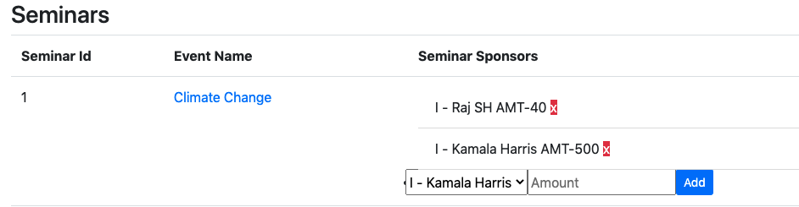

Sponsor read

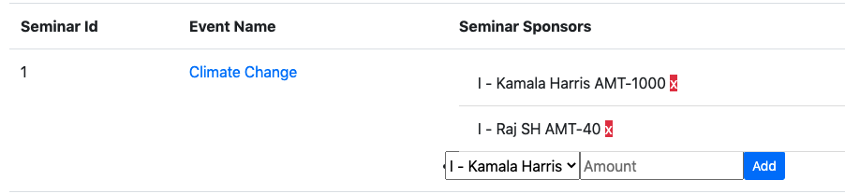

Sponsor update

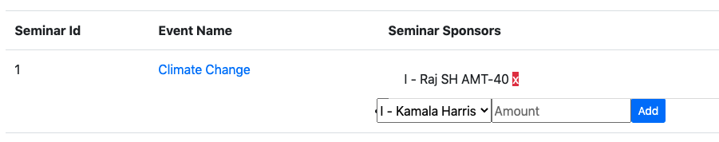

Sponsor delete(Previously added Kamala Harris is removed)

**Topic CRUD operation:**

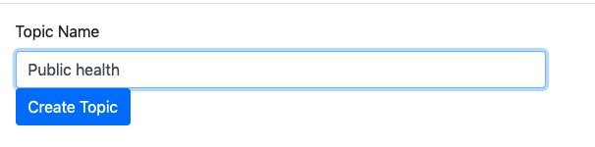

Event create

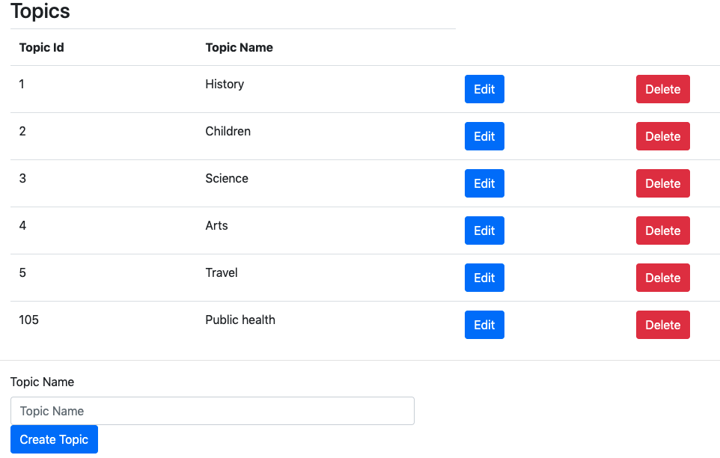

Event read

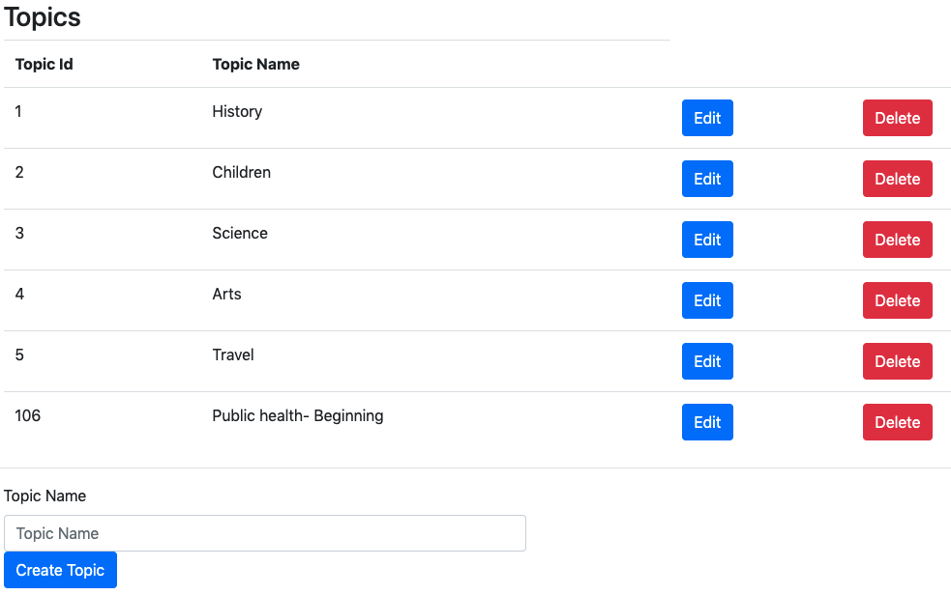

Event update(Public health is updated to Public health- Beginning)

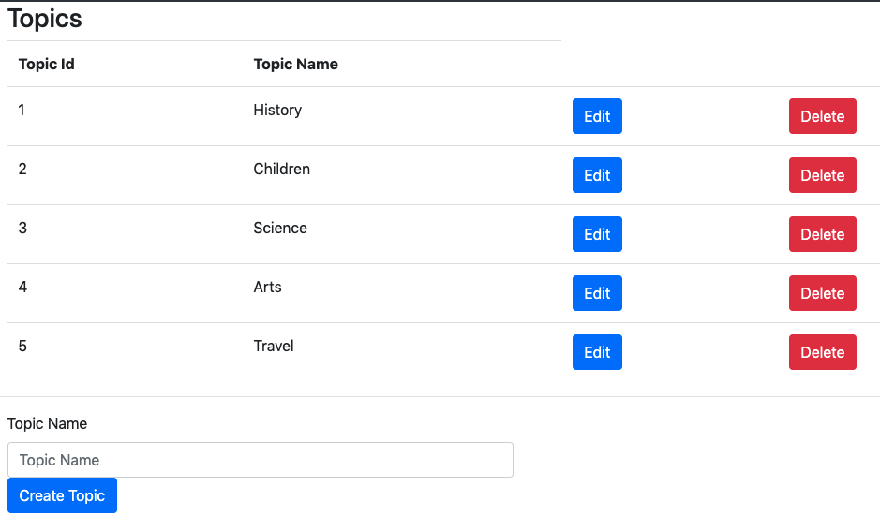

Event delete(Public health- Beginning is deleted)

Rooms (View, Add and Reserve)

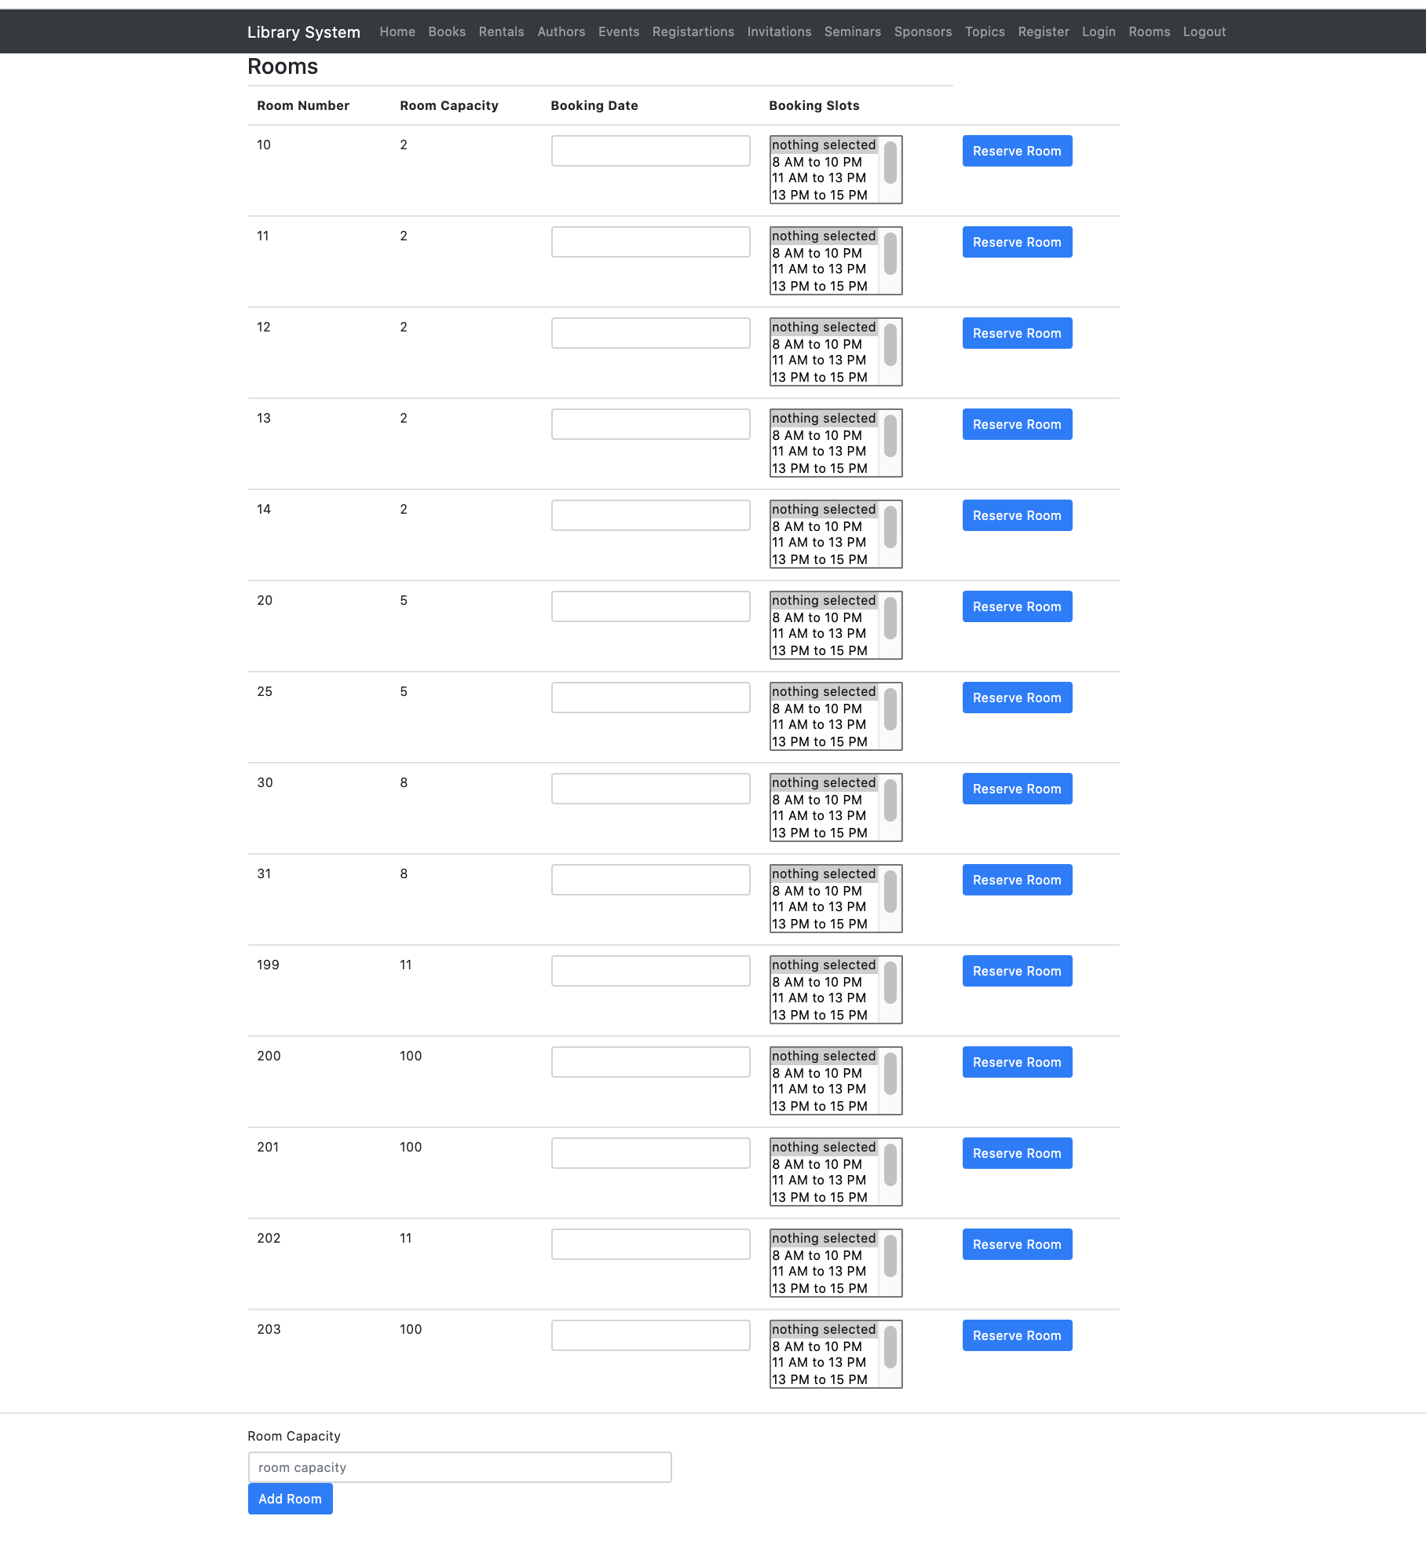

Topics (Add update delete) with list

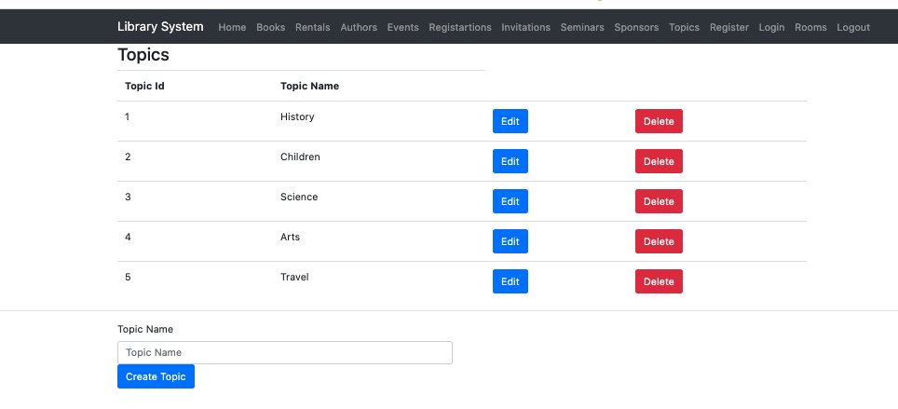

Add Book

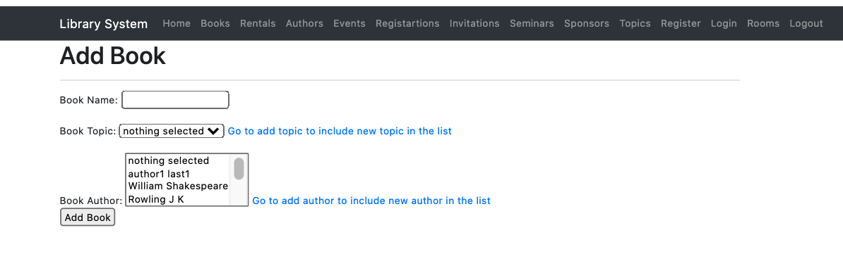

Edit Book

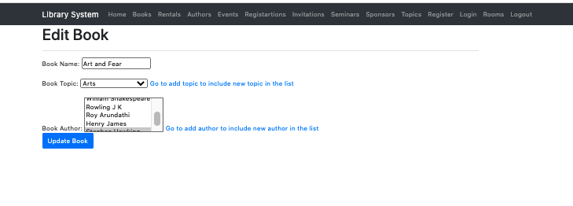

List and Delete Copies of Book

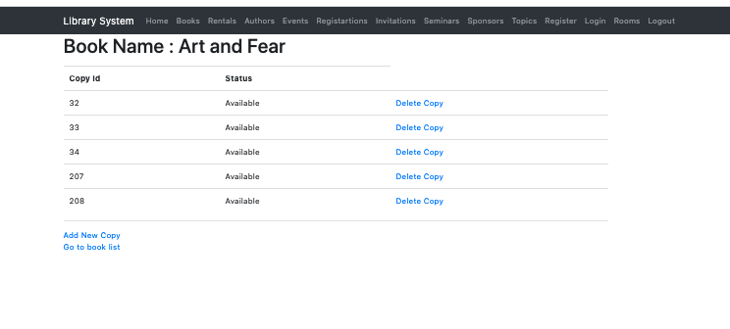

List of Books with links to add,edit,delete book and add/ delete Copies page.

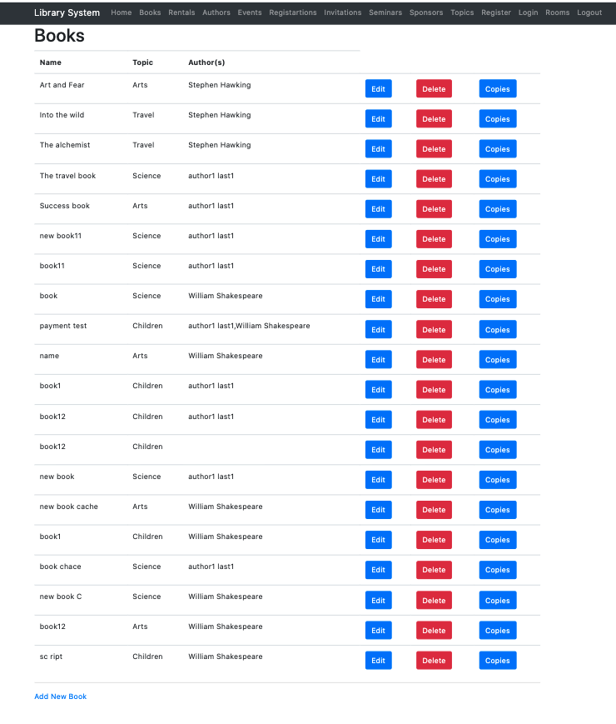

Rent a Book

(List of books with Status and option to rent accordingly)

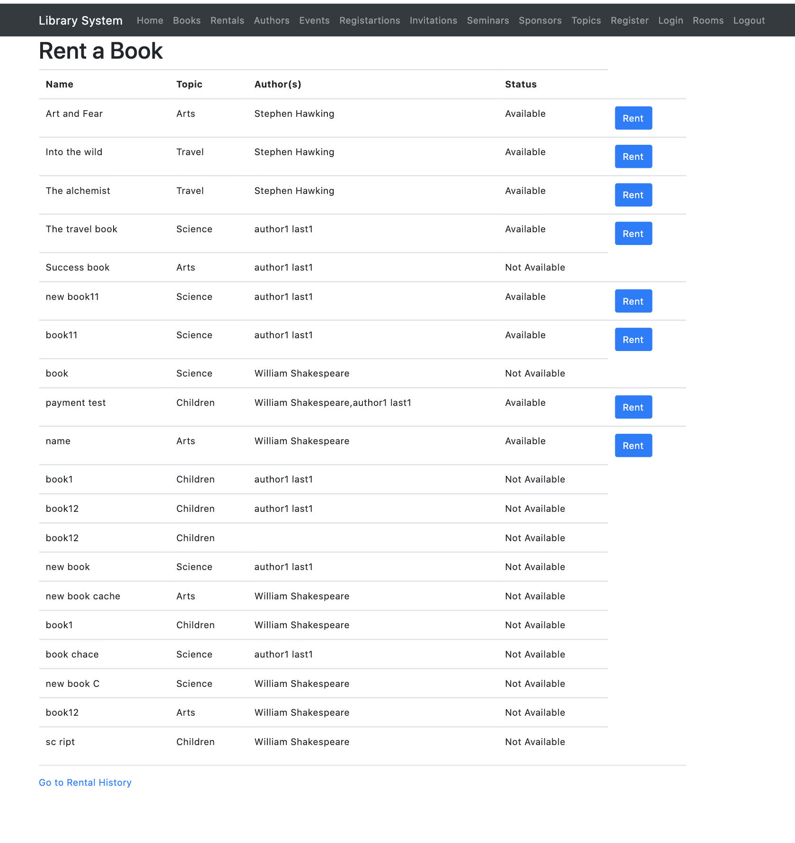

Rental History (With option to return book if not returned yet)

We can see here customer is allowed to rent more than one copies of same one book (example: rental id 209 and 107)

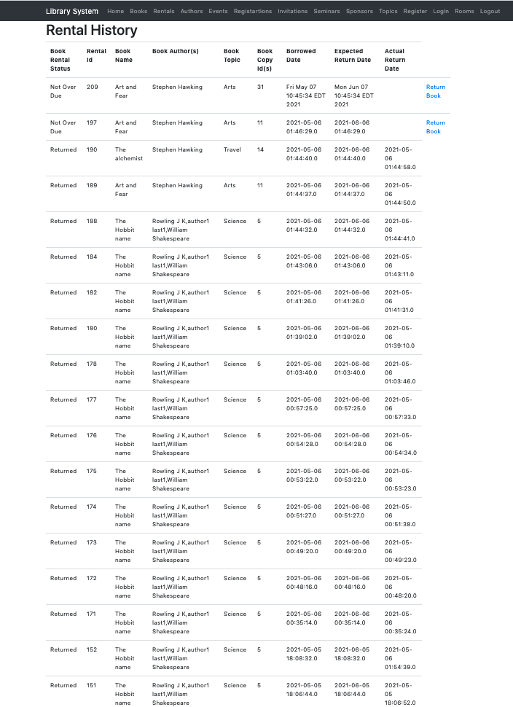

**Rental Payment page with 4 payment methods once user clicks on Return book on Rental History Page**

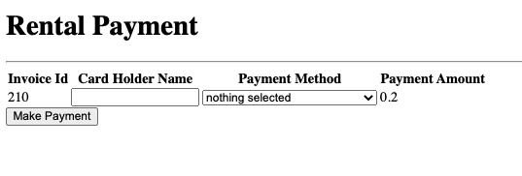

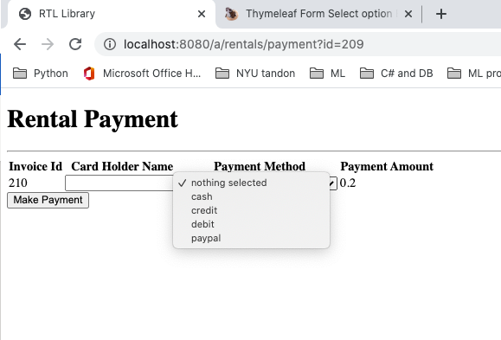

**Extra Features:**

**Mapped URLs to Web Components:**

When the web container receives a request, it determines which web component should handle the request. The web container does so by mapping the URL path contained in the request to a web application and a web component. A URL path contains the context root and, optionally, a URL pattern:

http://host:port/context-root[/url-pattern]

We followed this pattern to navigate to all our web pages.

Few Examples from our Web Platform:

* For books: <http://localhost:8080/a/books>

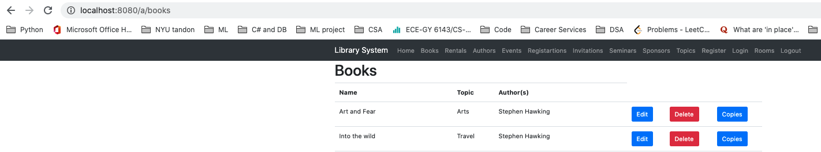

* For Rentals: <http://localhost:8080/a/rentals>

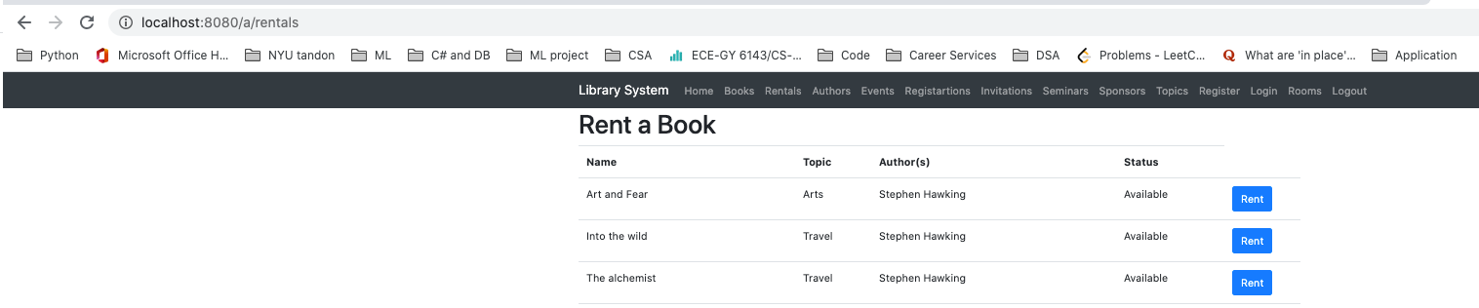

* For Authors: <http://localhost:8080/a/authors>

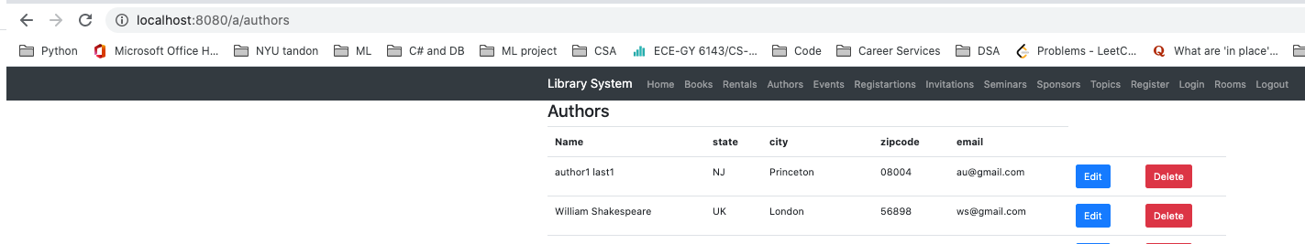

**Cross-Site Scripting and SQL Injections:**

Spring security’s built-in-functions are used to protect the application against reflected XSS and iFrame hijacking.

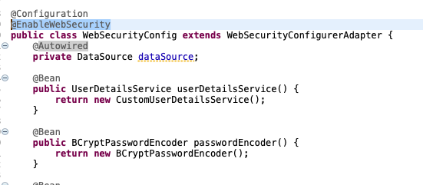

All the urls for the application were accessible only to authenticated users. We have also used role based authentication for different parts of application.

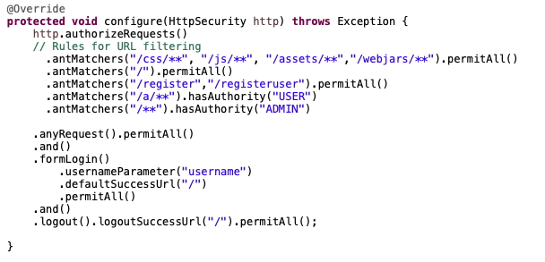

To prevent cross-site scripting and sql injection, Spring Data JPA framework interface along with Stored Procedures and functions is used.

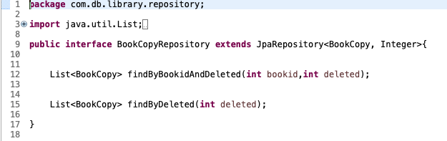

**Passwords:**

The Passwords of the users are automatically hashed with appropriate salt added to them. Even if an employee or admin logs in to the administrative site, they don’t have direct access to the full hash of the encrypted passwords, let alone the plaintext version.



**User Authentication:**

We have also made the login and registration page **redirect** to the user dashboard **if** the user is **already** **logged in**. We also made sure that, if someone exactly knows the URL to any user page, wemade them redirect to the login page, if they are not logged in using that username.

We have also made the login and registration page **redirect** to the user dashboard.



Login page



**Registration page**

**Form Validations:**

In the registration page, we are **alerted by** a **message** when we leave any field **blank**, or if **passwords don’t** **match**, or if they are too simple and **small**, or if they are too **like** the **username**, or if we don't entera valid email id. In the login page also, if we have entered incorrect details, we will be alerted via messages.

**Password Reset:**

We have also implemented password reset functionality, wherein the user enters his/her email address and a password reset link is sent, and user will be prompted to enter a new password, and it will be reset.

**Caching:**

we created a caching service where we fetch the list of books and store in the cache and every time when this method findByDeleted is called. It first checks from the cache named “Books” if it is empty it proceeds to get the list of books from database and populates the books cache.

@Cacheable("Books")

**public** List<Book> findByDeleted(**int** deleted)

We are clearing the “Books” cache if any update, delete or addition happens to book entity so that customers get the correct updated data.

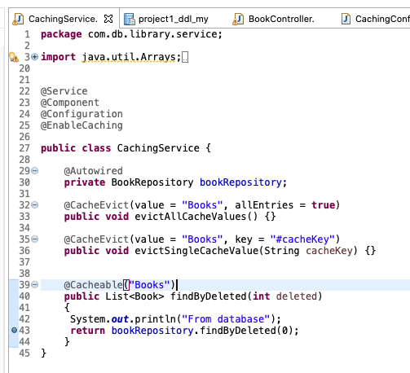



**Interesting data visualization and methods for user to interact with data:**

We provided add, update, delete,view from web page on all the main entities.   
Apart from giving the page to rent a Book for customers. We provided an additional page for all the users where they can see their rental history. It has all the necessary details (Rental id, book id, rentals status etc) for customer to view their past book rentals with the option to return book if not yet done. Once the book is returned customer will not get option to return and Book Rental stattus would be changed to return. This will also help customer to identify if any book is overdue. Using the status Column so that they can plan their rental activity accordingly.



**Stored procedures:**

Apart from using JPA entities and its functions to interact with database entities we also used stored procedure for fetching the history of Customer rental which is shown in above section.

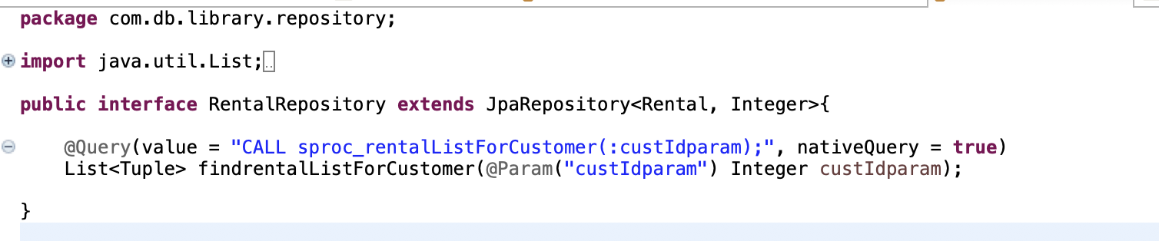

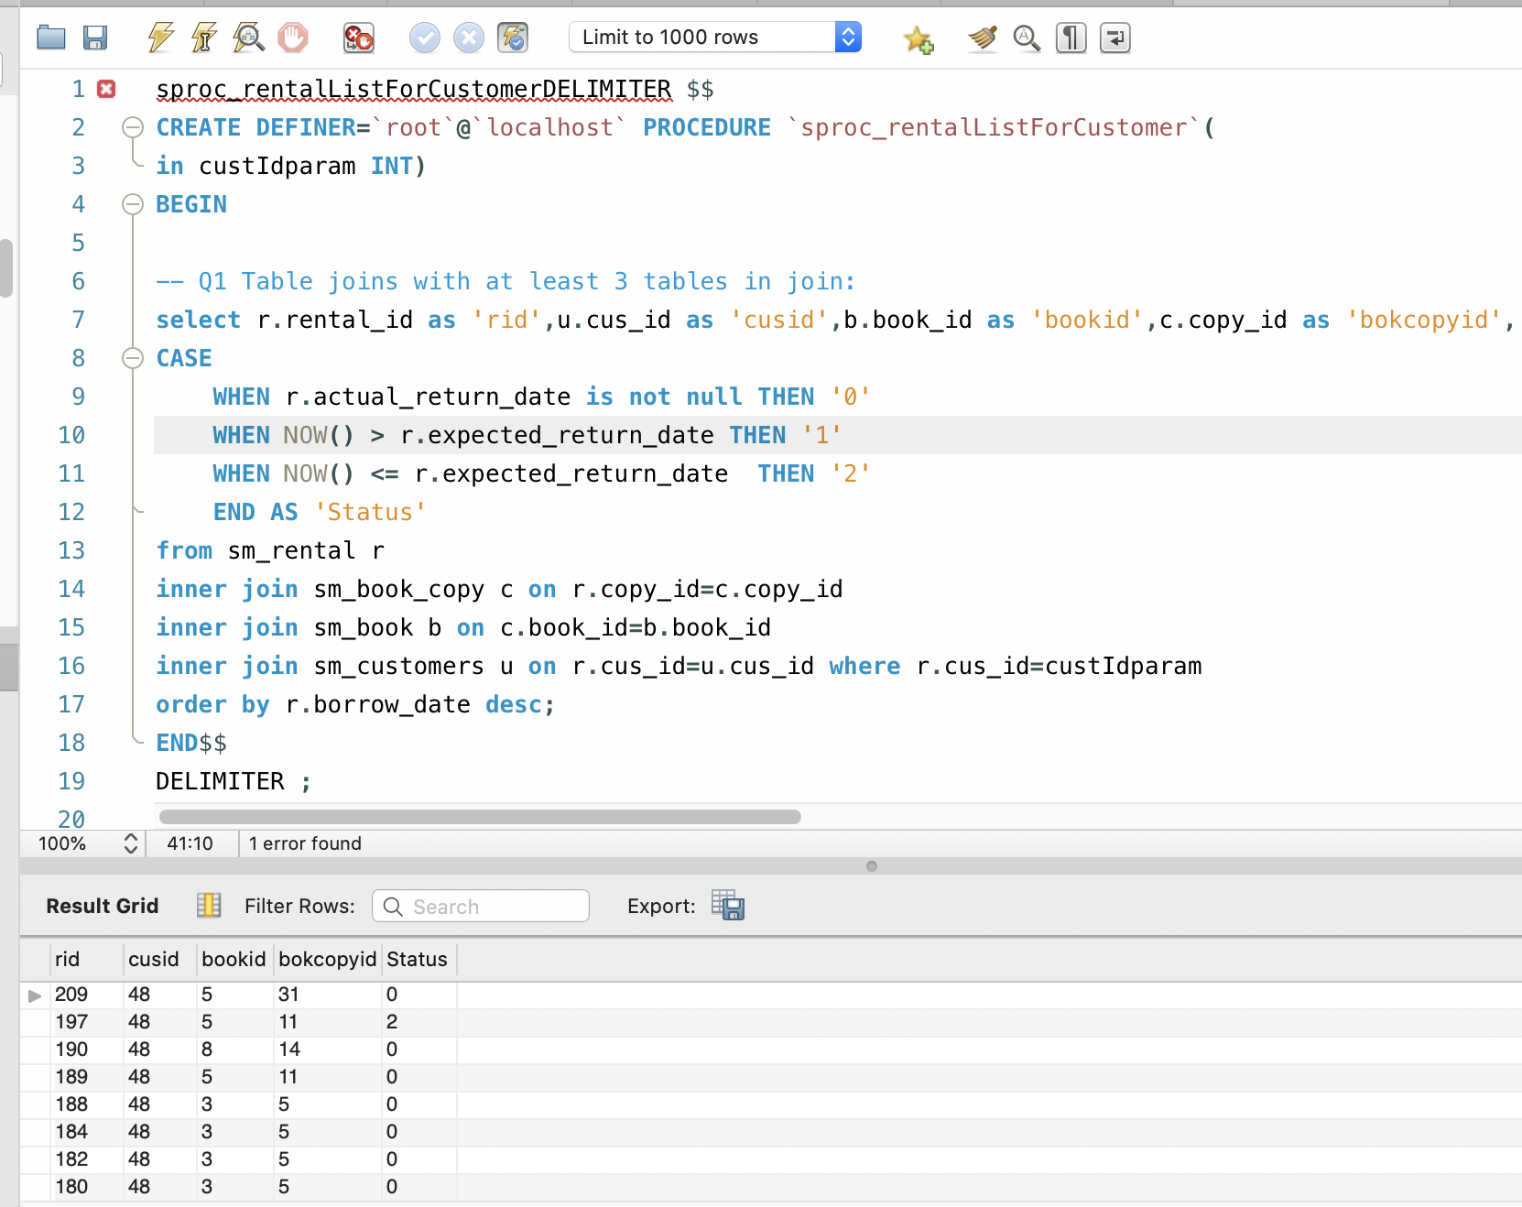



**User functions:**

This is how we fetch available copy_id for a given book_id. Only if at least one copy is available for the requested book, renting is possible.

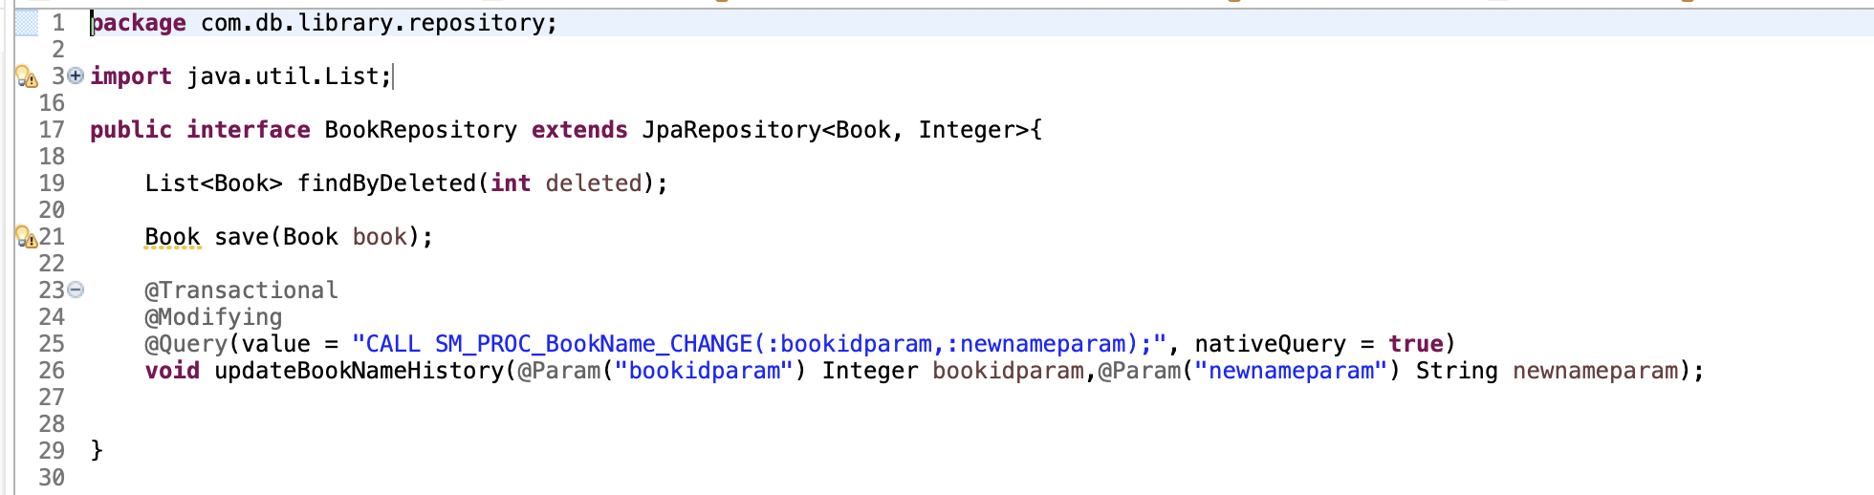

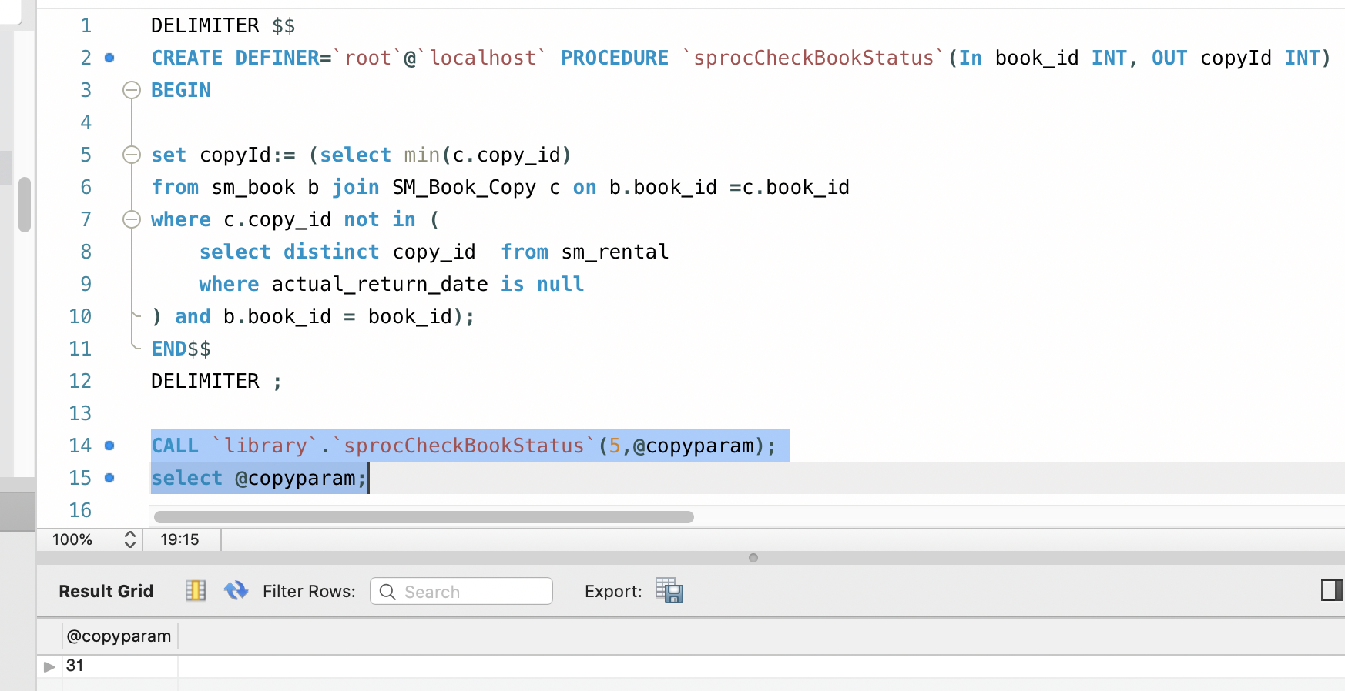

**This result used in Rent a book page to determine the availability of book.**

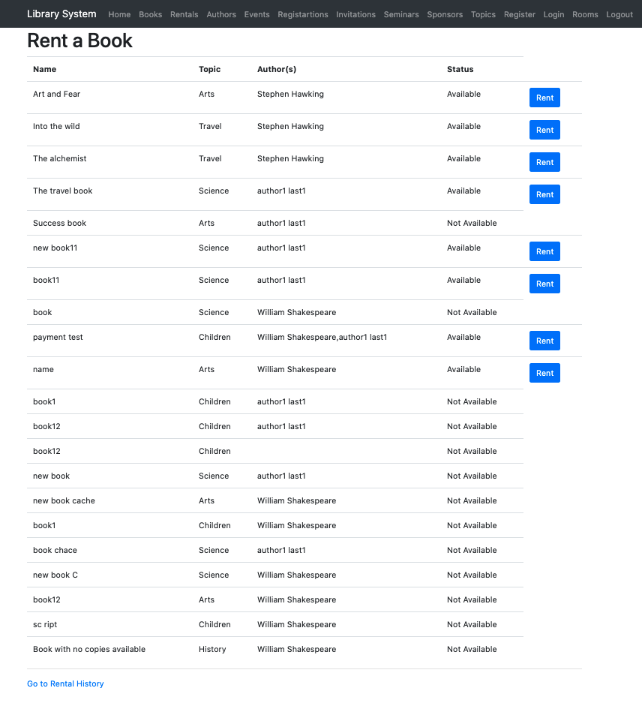

**History tables:**

We are using following history table to maintain the history of book name change to track update.

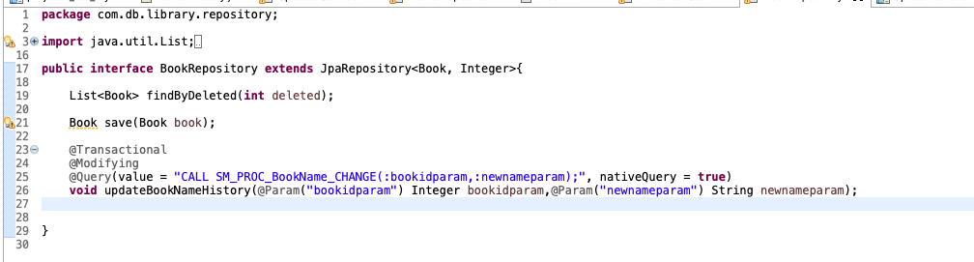

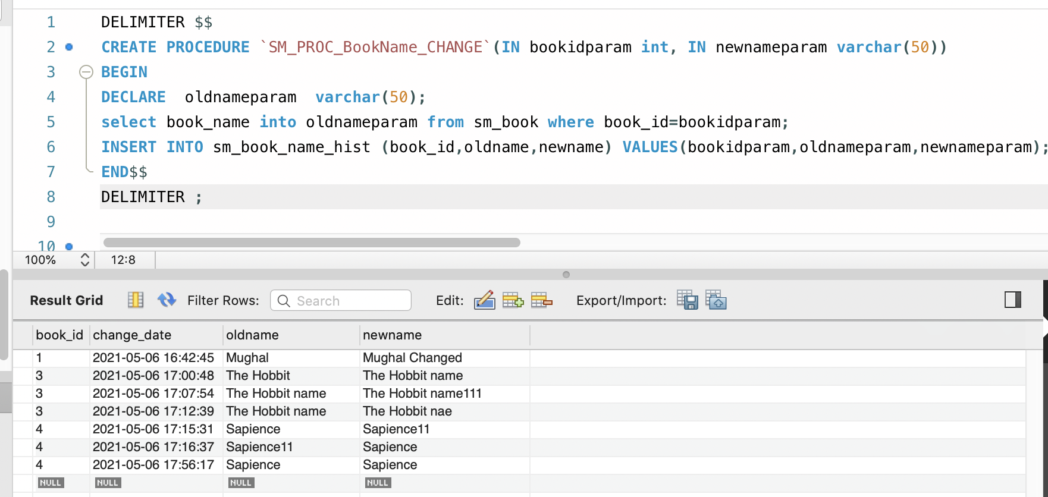

**Index:**

As it is a library management system and renting book is the main functionality therefore across this web app multiple places, we are fetching list of books which are not deleted. Upon deletion of books, we are setting the “Deleted” flag from 0 to 1 to indicate the book is deleted but for recording purpose we don’t do hard delete. Hot the purpose of renting we only show books which are not deleted (where deleted =1). Therefore, I have created an index **“idx_SM_BOOK_deleted”** in SM_Book table for column “deleted”. Which is being used in following query to increase the speed of book list fetching.

Select * from SM_Book where Deleted=0;

Index Creation :

**CREATE INDEX idx_SM_BOOK_deleted ON sm_book(deleted);**

We are assuming that Books are getting deleted and added in bulk only end of each Month. This index will not be updated very frequently hence it will not impact the performance adversely. As the data base grows we will have many deleted books so when fetching non deleted books for renting and other routine purposes we need to have an index which scans rows based upon Deleted column value which is 0 for active and 1 for deleted book.

**Before creating index:**

We can see that we have two indexes here:

Primary: on book_id

sm_book_sm_topics_fk: topic_id

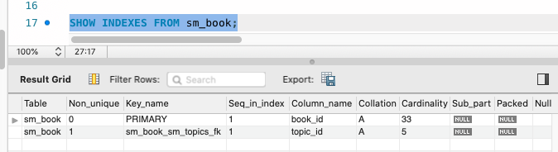

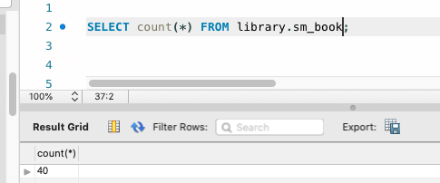

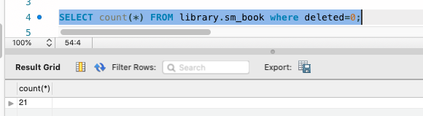

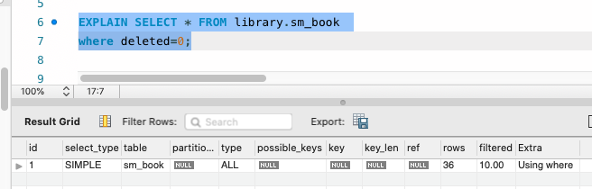

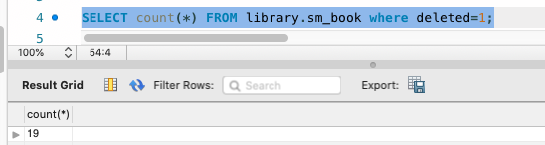

Query plan for **Select * from SM_Book where Deleted=0;** without deleted index.

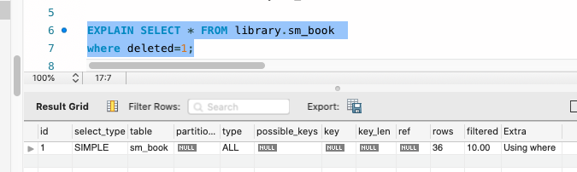

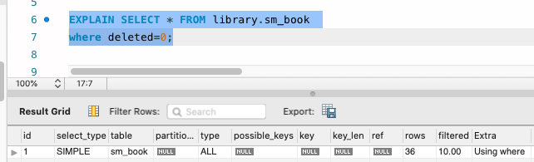

**We can see in the query plan that it is not using any key to search hence checking almost all rows to fetch the result which is not good for performance.**

**Post creation of Deleted index.**

**CREATE INDEX idx_SM_BOOK_deleted ON sm_book(deleted);**

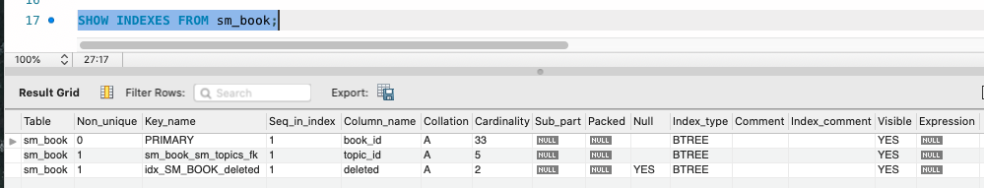

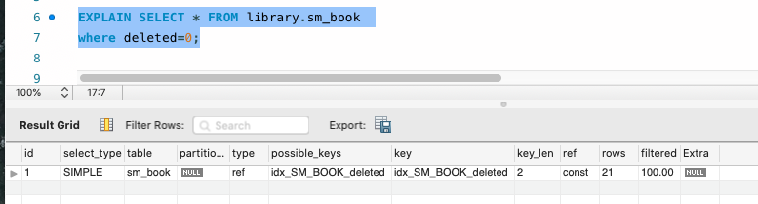

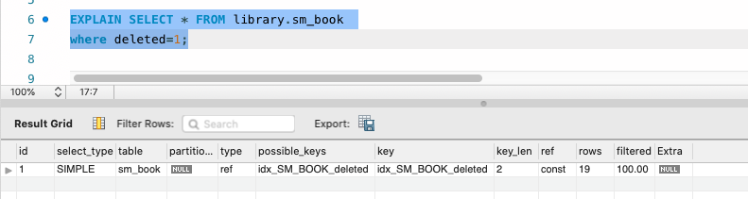

**We can see that the number of rows scanned in query in where clause changed from 36 to 21 and 19 which is the reduction of 41% and 47%. It increases the query performance enormously as the database grows every month.**

**Lessons Learned**

This Full Stack website design has opened a lot of untouched doors. We used to think that the backend part would be a lot easier, but the project states otherwise. This made us realise how complex database designs can be and how important it is to create an efficient design, create indexes and handle concurrency for a business. We also initially faced challenges in time management and team coordination, but later we figured it out what should be the versioning mechanism to work as a team and explored GITHUB. Working on such a small project made us realise the importance of communication, teamwork, leadership characteristics and domain knowledge one must possess to successfully deploy a real-world business use case.

**Business Analysis With MySQL:**

Q1) Table joins with at least 3 tables in join:

**Tables in join :** sm_rental , sm_book_copy, sm_book and sm_customers

**Result:** Customer Email Address, Customer Full Name, Book Name, Book Copy Id, Book Borrowed Date, Book Expected Returned Date, Book Actual Return Date, Rental Status

**Explanation: Book Rental Report** for library staff to view all the book rentals by all customers in the ascending order of Book Borrowed Date with Rental Status - if ‘Book Actual Return Date’ is not null then its status is returned. if, Book Actual Return Date’ is null and if its ‘Book Expected Returned Date’ is passed then it is 'On Rent - Overdue' else 'On Rent – Not Overdue'.

**Query:**

select u.email_address as 'Customer Email Address',CONCAT(u.f_name,' ',u.l_name) as 'Customer Full Name',

b.book_name as 'Book Name',c.copy_id as 'Book Copy Id',r.borrow_date as 'Book Borrowed Date',r.expected_return_date as 'Book Expected Returned Date',

r.actual_return_date as 'Book Actual Return Date',

CASE

WHEN r.actual_return_date is not null THEN 'Returned'

WHEN NOW() > r.expected_return_date THEN 'On Rent - Overdue'

WHEN NOW() <= r.expected_return_date THEN 'On Rent - Not Overdue'

END AS 'Rental Status'

from sm_rental r

inner join sm_book_copy c on r.copy_id=c.copy_id

inner join sm_book b on c.book_id=b.book_id

inner join sm_customers u on r.cus_id=u.cus_id order by r.borrow_date desc

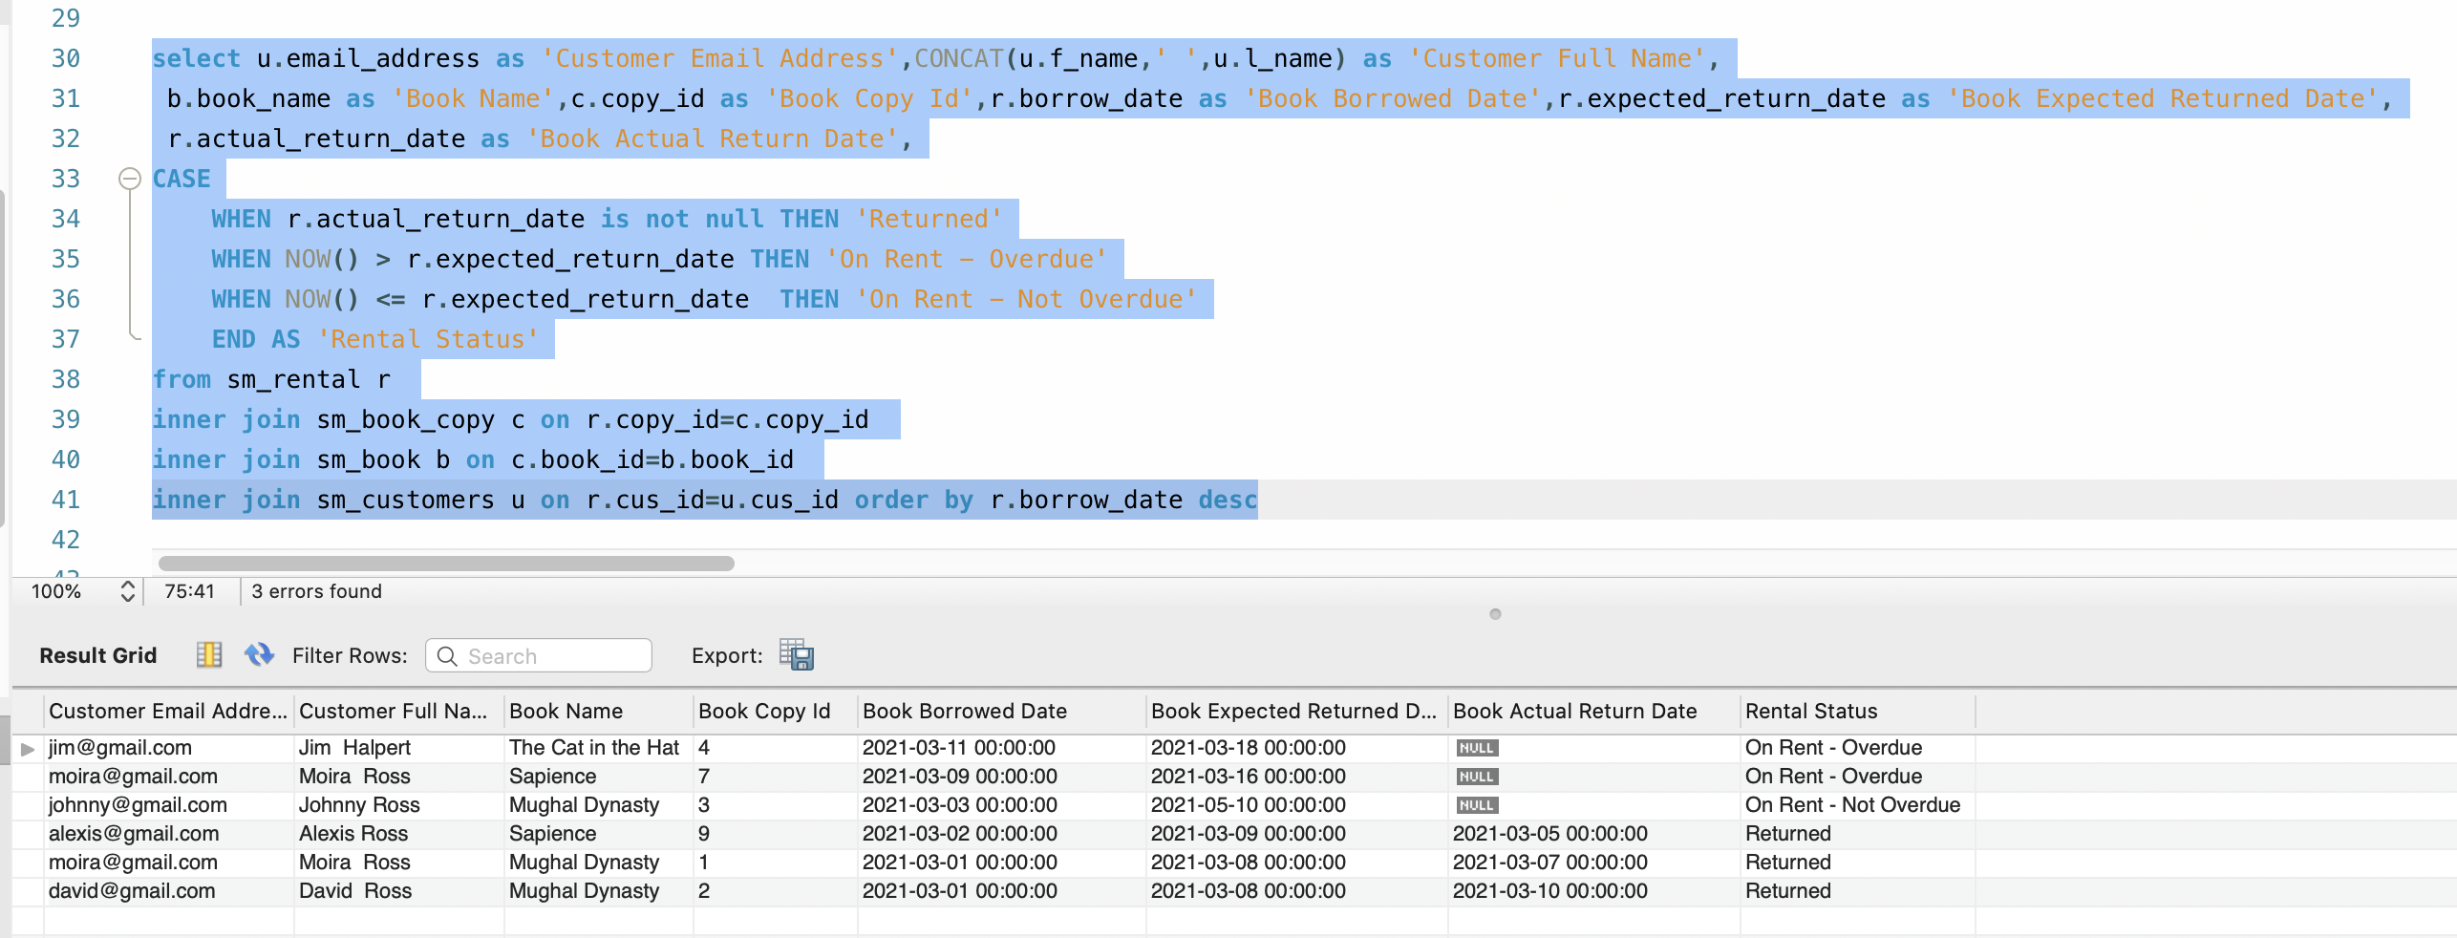

Q2) Multi-row subquery:

**Subquery :** Getting the details of events of type Exhibition which have registration count less than 100 to help in planning events better.

**Result:** Event Id, Event Name, Event Start Datetime, Event Stop Datetime, Topic Name

**Explanation: Seminar Registration Analysis Report** for library staff to view which Exhibition has registrations less than 100. This query result includes event id , topic, event start and stop time to help in the analysis.

**Query:**

select e.event_id as 'Event Id',e.event_name as "Event Name",e.event_start_datetime as "Event Start Datetime",

e.event_stop_datetime as "Event Stop Datetime",T.topic_name as "Topic Name"

from (

select * from sm_events where event_id

in

(SELECT e.event_id FROM sm_registration as r right outer join sm_exhibition as e on r.event_id=e.event_id

group by e.event_id having count(*) <100)) as e inner join sm_topics as T on e.topic_id=T.topic_id;

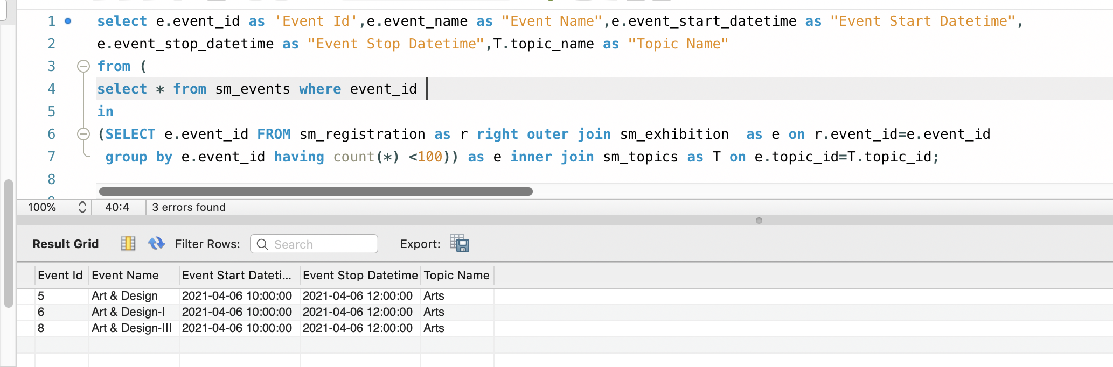

Q3) Correlated subquery:

**Subquery :** Getting the details of rooms (room id, room capacity) which had ever been booked in past one month so that library admin can allocate recourses correctly for maintenance since resources in these rooms must be used more frequently than others.

**Result:** Room Id, Room Capacity

**Explanation: Study Room Reservation Analysis Report** for library staff to view which Rooms have been booked at least once in past one month. This query result includes Room Id, Room Capacity to help in the resource allocation.

**Query:**

Select r.room_id as "Room Id",r.room_capacity as "Room Capacity" from sm_study_room r where exists

(select * from sm_reservations where room_id=r.room_id and (reservation_date <= now() and reservation_date >= DATE_SUB(NOW(), INTERVAL 1 MONTH)))

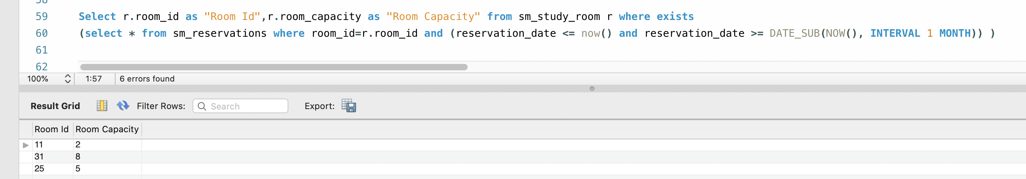

**Q4) SET operator query:**

**Union:** we are doing union of results of two queries

query: 1 is giving the list of organizations which are added in the system as sponsor but not contributing at all.

query: 2 is giving the list of individuals which are added in the system as sponsor but not contributing at all.

Doing union of all of Query 1 and 2, gives us unique sponsors (Id and Name) with types (individuals and organizations) which have no contributions in the seminars.

**Result:** Customer Email Address, Customer Full Name, Book Name, Book Copy Id, Book Borrowed Date, Book Expected Returned Date, Book Actual Return Date, Rental Status

**Explanation: Seminar Sponsor Analysis:** Report for library staff to view which sponsors are not contributing at all in seminars and can approach them accordingly to improve the donation for encouraging more seminars event in library.

**Query:**

select sponsor_id as 'Id',T.Type, org_name as 'Name' from sm_organization,(select 'Organization' as "Type" from dual) as T

where sponsor_id not in (SELECT sponsor_id FROM SM_Seminar_Sponsor)

union

select sponsor_id as 'Id',T.Type,CONCAT(first_name," ",last_name) as 'Name' from sm_individual,(select 'Individual' as "Type" from dual) as T

where sponsor_id not in (SELECT sponsor_id FROM SM_Seminar_Sponsor) order by Id

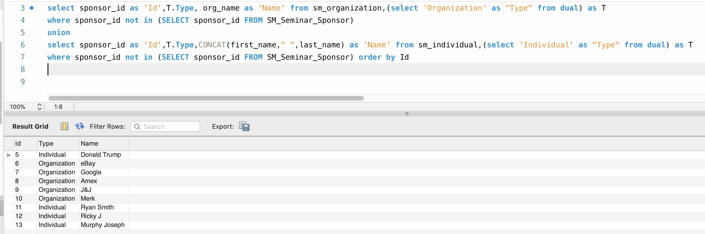

**Q5) Query with in line view or WITH clause**

**View Name:** sm_view_rental_payment

**Result:** Rental Id, Customer Id, Customer Full Name, Customer Email Address, Total Invoice Amount, Total Amount Paid, Total Amount Owed

**Explanation:** Outstanding Amount Report - Using this query, library staff can view all the book rentals which have outstanding due amount which is unpaid by any customer in the ascending order of Customer Full Name. Using this report library staff can see for which rental, customer has outstanding balance using “Rental Id” and can send reminder mail to them to pay the due amount using “Customer Email Address” field.

**Query:**

with sm_view_rental_payment as

(select a.rental_id,a.invoice_id, a.invoice_amount,COALESCE(sum(b.payment_amount),0) as 'aumout_paid',

(a.invoice_amount - COALESCE(sum(b.payment_amount),0)) as "amount_owed" from sm_invoice a left outer join sm_payment b on a.invoice_id=b.invoice_id

group by a.rental_id)

select b.rental_id as 'Rental Id',a.cus_id as 'Customer Id',CONCAT(a.f_name,' ',a.l_name) as 'Customer Full Name',a.email_address as "Customer Email Address",

d.invoice_amount as "Total Invoice Amount",d.aumout_paid as "Total Amount Paid",d.amount_owed as "Total Amount Owed"

from sm_customers a join sm_Rental b on a.cus_id=b.cus_id

join sm_view_rental_payment d on d.rental_id=b.rental_id

order by CONCAT(a.f_name,' ',a.l_name);

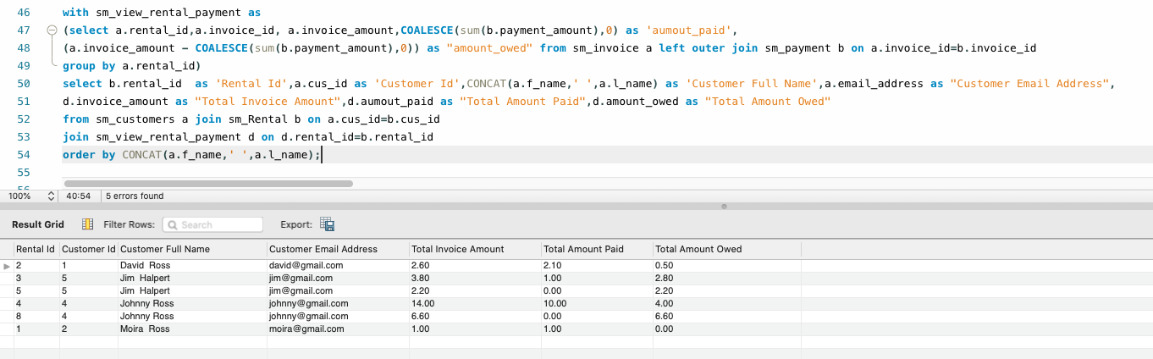

**Cross**

**Q6) TOP-N query**

**Top-N:** Ranking Authors based upon number of rentals in desc order of their book copies within last 6 months.

“rank () over (order by count(b.rental_id) desc) as authorRank”

**Result:** Author Id, Author Full Name, Author Email, Number of Copies Got Rented, authorRank

**Explanation: Top Selling Author Report** - Using this query, library staff can view top 2 bestselling authors based upon how many times, copies of their book got rented in last 6 months. This query will help them to plan the purchase of new copies of books. Library staff can also contact these best- selling authors, using Author Email and other details provided by this query, to plan for seminars and other events in library.

**Query:**

WITH AuthorRank

AS (

Select e.author_id as "Author Id" , CONCAT(e.First_Name," ",e.Last_Name) as 'Author Full Name',

e.email as "Author Email",count(b.rental_id) as 'Number of Copies Got Rented',

rank () over (order by count(b.rental_id) desc) as authorRank

from sm_Book_Copy a

join sm_rental b on a.copy_id=b.copy_id

join sm_Book c on a.book_id=c.book_id

join sm_Book_Author d on d.book_id=c.book_id

join sm_Authors e on d.author_id=e.author_id where (borrow_date <= now() and borrow_date >= DATE_SUB(NOW(), INTERVAL 6 MONTH)) group by e.author_id)

select * from AuthorRank where authorRank<3

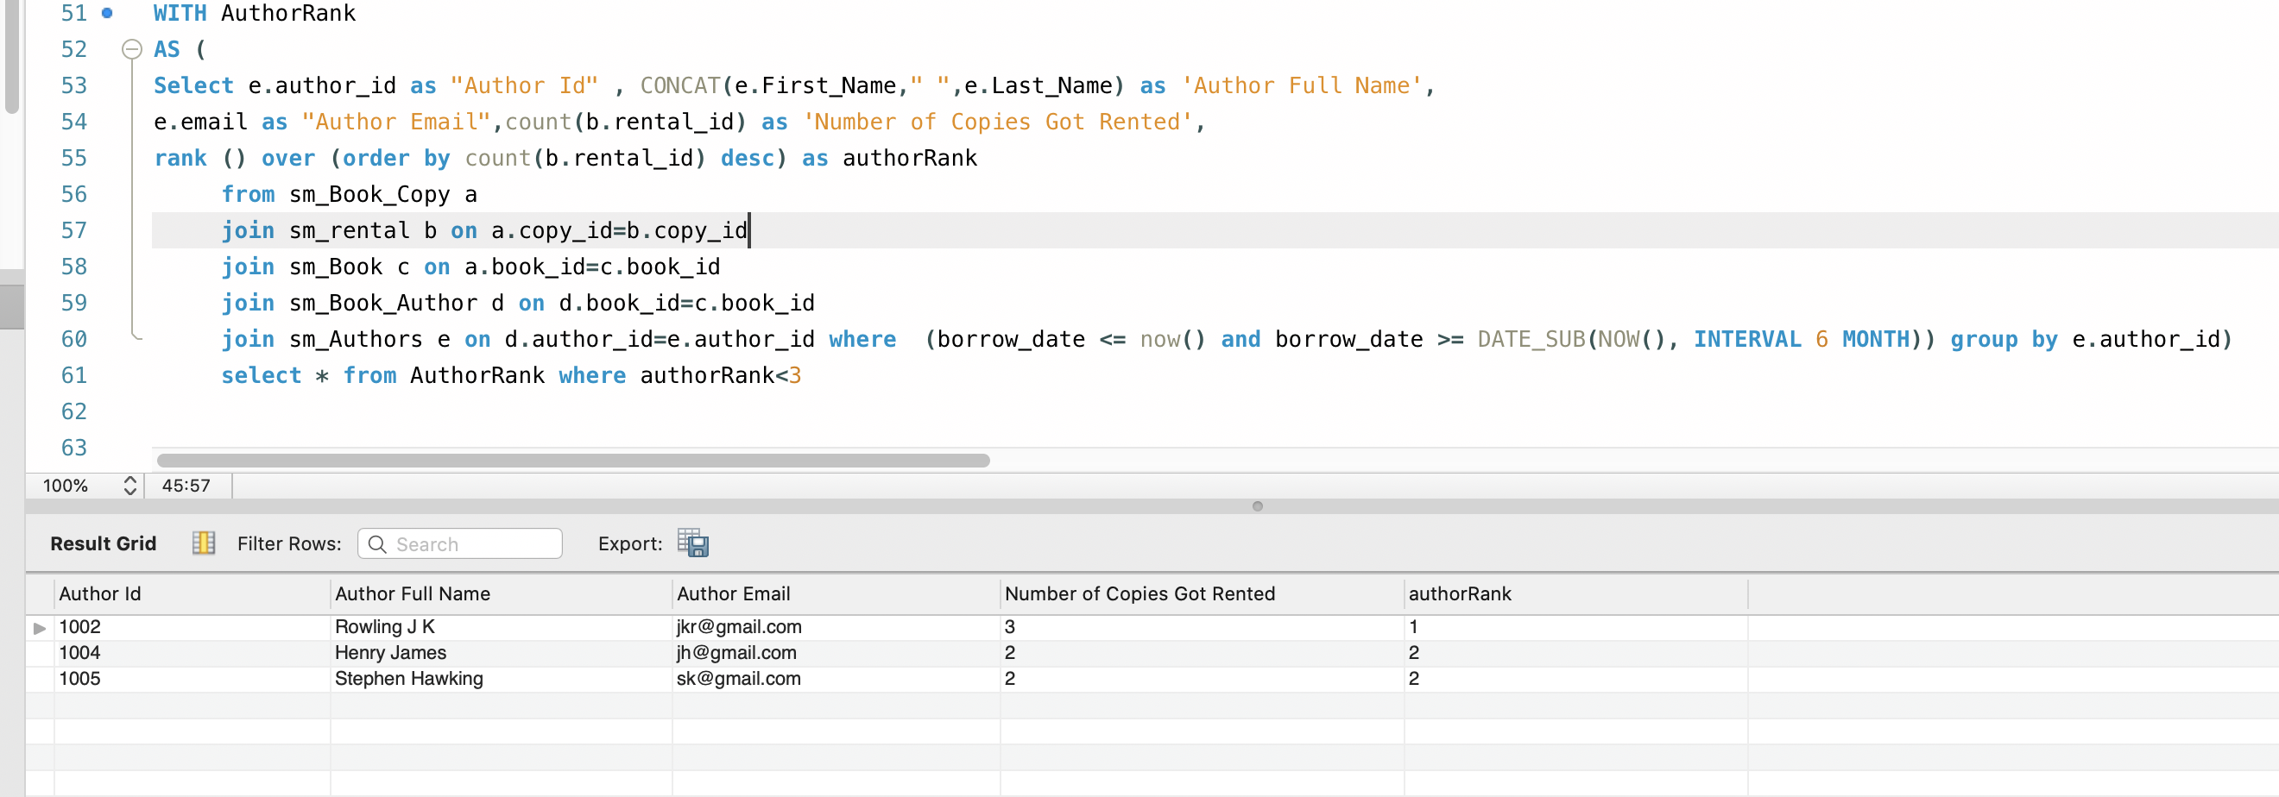

References:

[1] <https://www.codejava.net/frameworks/spring-boot/user-registration-and-login-tutorial>

[2] <https://www.thymeleaf.org/doc/tutorials/3.0/usingthymeleaf.html>

[3] <https://www.toptal.com/spring/beginners-guide-to-mvc-with-spring-framework>

[4] <https://spring.io/guides/gs/securing-web/>